The UK – miniproject

You’ll work in pairs. First find all the information and then make your project. You’ll need the Internet, paper size A 3, scissors, glue, coloured pencils or you can create your presentation in PowerPoint.

Questions

1. What is Great Britain? (Which countries make up GB?)
2. What is the UK? (Which countries make up the UK?)
3. Label the countries and colour them each a different colour.
4. Label the capitals, mark them with a star.
5. Colour the flags a match them to the countries.
6. Find out more about UK’s flag. What is the name of the flag of UK a nd what is the combination of?
7. Each country in the UK has its own patron and floral emblem. Find out more about symbols (write the English name of the Flowers and clour them), write the names of the patrons and match them to the countries.

Useful weblinks

[www.enchantedlearning.com/school/Britain](http://www.enchantedlearning.com/school/Britain)

<http://woodlands-junior.kent.sch.uk/customs/questions/flag.html>

<http://projectbritain.com/flowers.html>

<http://www.projectbritain.com/uk.htm>

[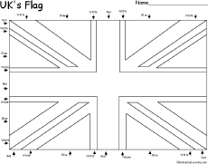](http://www.enchantedlearning.com/europe/britain/flag.shtml) [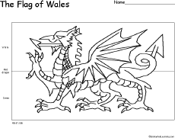](http://www.enchantedlearning.com/geography/flags/europe.shtml)

[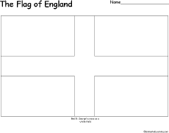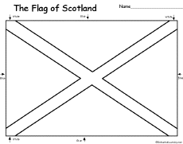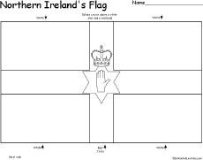](http://www.enchantedlearning.com/geography/flags/europe.shtml)

[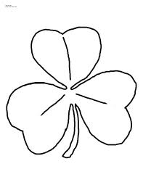](http://www.google.cz/imgres?q=irsk%C3%BD+trojl%C3%ADstek&hl=cs&sa=X&rls=com.microsoft:cs&biw=1280&bih=697&tbm=isch&tbnid=0s2la6QTh9dVYM:&imgrefurl=http://color-your-own.com/holiday_shamrock_coloring_page.html&docid=R-J4MoP70VFseM&w=2550&h=3300&ei=jSpZTr-iOcP5sgbKhYTWCg&zoom=1)[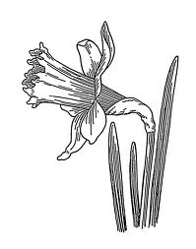](http://www.google.cz/imgres?q=narcis&hl=cs&rls=com.microsoft:cs&biw=1280&bih=697&tbm=isch&tbnid=K4aqm4Yq0HjWTM:&imgrefurl=http://wiki.rvp.cz/Kabinet/0.0.0.Kliparty/Kv%C4%9Btiny/Jarn%C3%AD_kv%C4%9Btiny_-_%C4%8Dernob%C3%ADl%C3%A9_obr%C3%A1zky_(smetanka,_tulip%C3%A1n,_krokus,_sn%C4%9B%C5%BEenka,_bledule,_mod%C5%99enec,_narcis,_konvalinka,_violka,_kopretina,_mace%C5%A1ka,_...)&docid=-Ai9P4_k_qk1eM&w=943&h=1200&ei=ESxZTv_FKITRsgbLvtCICw&zoom=1)[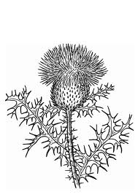](http://www.google.cz/imgres?q=bodl%C3%A1k&hl=cs&rls=com.microsoft:cs&biw=1280&bih=697&tbm=isch&tbnid=Cce4gEGebm2ftM:&imgrefurl=http://www.justflower.org/thistle-15.html&docid=RiwyT5i4f4aSXM&w=620&h=875&ei=lC1ZTuvmMsjCswaC09ykCw&zoom=1)[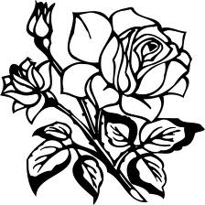](http://www.google.cz/imgres?q=r%C5%AF%C5%BEe&hl=cs&sa=X&rls=com.microsoft:cs&biw=1280&bih=697&tbm=isch&tbnid=5_NFdIqUTjVnJM:&imgrefurl=http://potisky-tricek.reklamtisk.cz/?p=ordersBasket&sOption=add&iProduct=31&iQuantity=1&docid=nRd3Rulg5PDmwM&w=550&h=550&ei=LC5ZTvntD5DMswbe482aCw&zoom=1)

[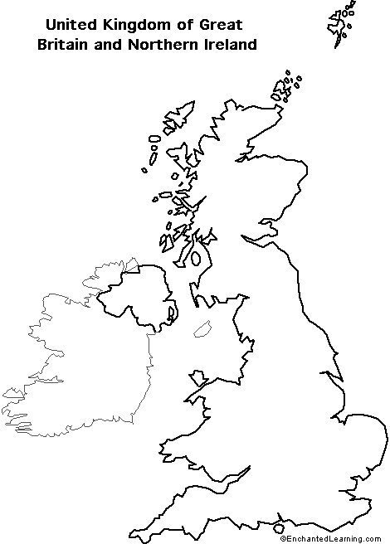](http://www.enchantedlearning.com/geography/europe/)

Zdroje

<http://www.enchantedlearning.com/europe/uk/flag/Flagbwhuge.shtml>

<http://www.enchantedlearning.com/europe/wales/flag/Flagbwhuge.shtml>

<http://www.enchantedlearning.com/europe/britain/scotland/flag/Flagbwhuge.shtml>

<http://www.enchantedlearning.com/europe/northernireland/flag/Flagbwhuge.shtml>

<http://www.enchantedlearning.com/europe/britain/england/flag/Flagbwhuge.shtml>

<http://color-your-own.com/holiday_shamrock_coloring_page.html>

<http://www.google.cz/imgres?q=narcis&hl=cs&rls=com.microsoft:cs&tbm=isch&tbnid=K4aqm4Yq0HjWTM:&imgrefurl=http://wiki.rvp.cz/Kabinet/0.0.0.Kliparty/Kv%25C4%259Btiny/Jarn%25C3%25AD_kv%25C4%259Btiny_-_%25C4%258Dernob%25C3%25ADl%25C3%25A9_obr%25C3%25A1zky_(smetanka,_tulip%25C3%25A1n,_krokus,_sn%25C4%259B%25C5%25BEenka,_bledule,_mod%25C5%2599enec,_narcis,_konvalinka,_violka,_kopretina,_mace%25C5%25A1ka,_...)&docid=-Ai9P4_k_qk1eM&w=943&h=1200&ei=AixZTp6ZKY7bsgbb5IXKCg&zoom=1&iact=rc&page=4&tbnh=174&tbnw=137&start=56&ndsp=15&ved=1t:429,r:3,s:56&tx=86&ty=55&biw=1280&bih=697>

<http://www.justflower.org/thistle-15.html>

<http://www.google.cz/imgres?q=r%C5%AF%C5%BEe&hl=cs&sa=X&rls=com.microsoft:cs&tbm=isch&tbnid=5_NFdIqUTjVnJM:&imgrefurl=http://potisky-tricek.reklamtisk.cz/%3Fp%3DordersBasket%26sOption%3Dadd%26iProduct%3D31%26iQuantity%3D1&docid=nRd3Rulg5PDmwM&w=550&h=550&ei=_y1ZToWwHNDHsgbEyazgCg&zoom=1&iact=hc&vpx=952&vpy=309&dur=1136&hovh=224&hovw=224&tx=133&ty=76&page=14&tbnh=169&tbnw=169&start=196&ndsp=17&ved=1t:429,r:9,s:196&biw=1280&bih=697>

[www.enchantedlearning/geography/europe](http://www.enchantedlearning/geography/europe)