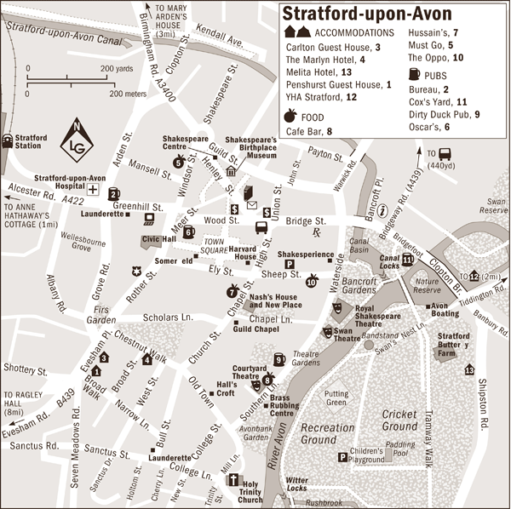

A/ I am at the Stratford Station:

- How do I get to the Firs Garden?
- How do I get to the Swan Theatre?
- Where can I eat in Stratford-upon-Avon?
- Where can I sleep in Stratford-upon-Avon?
- Where is the children´s playground? How do I get there?

B/ I am at the Holy Trinity Church:

- How do I get to the Courtyard Theatre?
- How do I get to the Cricket Ground?
- Where is the town square? How do I get there?
- Where is the post office?
- Where is the Shakespeare´s Birthplace Museum?

Zdroj obrázku:

http://www.letsgo.com/maps/europe/england/stratford-upon-avon

