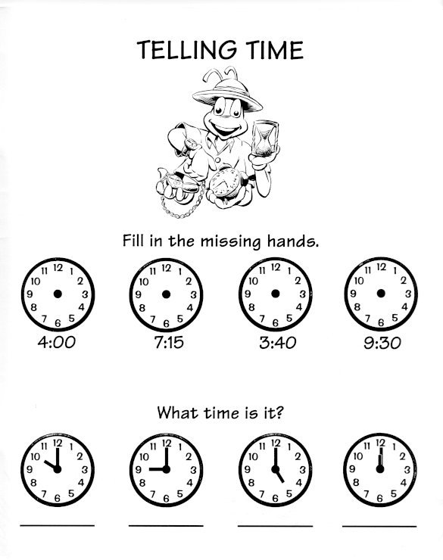

TELLING TIME – PRESENT SIMPLE

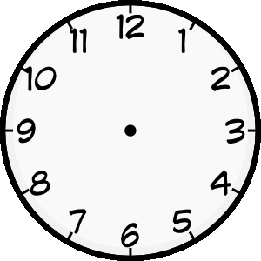
Doplňte časový údaj, kdy danou aktivitu děláte. Vytvořte věty o sobě podle nápovědy.

 |  | read a book
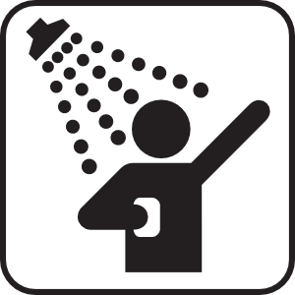 |  | have a shower
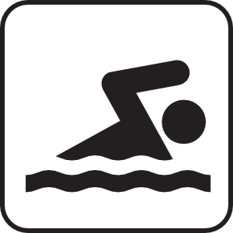 |  | go swimming
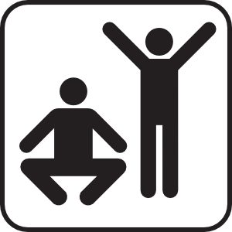 |  | exercise
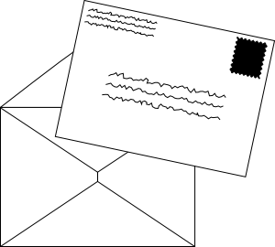 |  | write a letter
 |  | phone my friend
 |  | go shopping
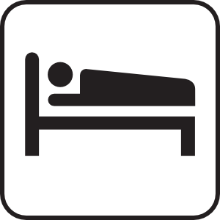 |  | go to bed

Zdroj obrázků:

http://www.archjrc.com/childsplace/images/time.gif
http://www.clker.com/clipart-person-reading-book1.html
http://www.clker.com/clipart-showers1.html
http://www.clker.com/clipart-swimming1.html
http://www.clker.com/clipart-map-symbols-exercise-fitness-white.html
http://www.clker.com/clipart-9287.html
http://www.clker.com/clipart-8085.html
http://www.clker.com/clipart-10390.html
http://www.clker.com/clipart-sleeping-accomodations-map-symbol1.html
http://www.clker.com/clipart-television.html

